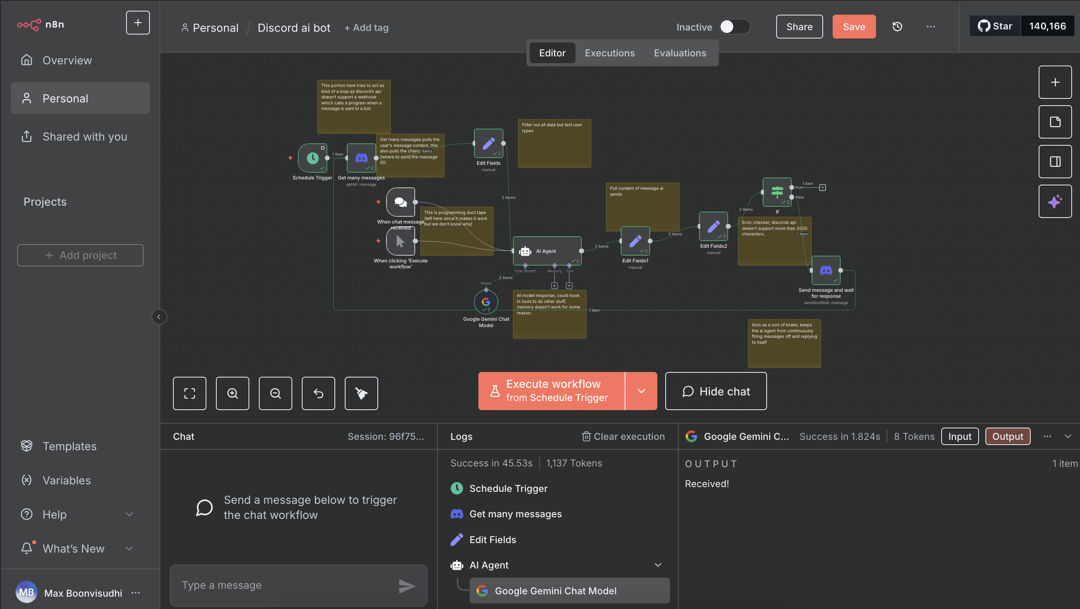

This workflow connects a Discord bot to an AI agent allowing it to read user messages and generate intelligent replies. Since Discord’s API does not provide a direct webhook when a user messages a bot, ([Source](https://discord.com/developers/docs/events/gateway-events) ) the workflow uses a scheduled trigger to repeatedly check the channel for new messages. The “Get many messages” node retrieves the latest user input, which is then passed through a “Set” node to isolate the text. That text is fed into the AI Agent node, which communicates with the Google Gemini API to create a response.

The AI’s output is processed through a series of “Set” and “If” nodes to ensure that the reply does not exceed Discord’s 2000-character limit([Source](https://www.reddit.com/r/discordapp/comments/8bmpzq/do_bots_have_2000_character_limit/)). If the response is valid, the bot sends the message back to the same channel and waits for further input. Additional logic is built in to prevent the agent from replying to itself, which could cause infinite loops.

[2025-09-23 20-00-17.mov](https://jacksonvilleedu-my.sharepoint.com/:v:/g/personal/mboonvi_jacksonville_edu/Ea1Xgt1dVONKggJer1Lt8L8BCHlfECL8dAxRFVddakoCfA?nav=eyJyZWZlcnJhbEluZm8iOnsicmVmZXJyYWxBcHAiOiJTdHJlYW1XZWJBcHAiLCJyZWZlcnJhbFZpZXciOiJTaGFyZURpYWxvZy1MaW5rIiwicmVmZXJyYWxBcHBQbGF0Zm9ybSI6IldlYiIsInJlZmVycmFsTW9kZSI6InZpZXcifX0%3D&e=5ZeACB)